**“SQL Assignment Submission- (Vikas Kumar Maurya) “**

**VIKAS KUMAR MAURYA**

[**VIKASM16794@GMAIL.COM**](mailto:VIKASM16794@GMAIL.COM)

**BUSINESS ANALYST**

**Assignment – SQL [Major]**

**CREATE database weather_observation;**

**USE weather_observation;**

***-- Q1) Create a table “STATION” to store information about weather observation stations:***

CREATE TABLE STATION (ID INT PRIMARY KEY,

CITY CHAR (20),

STATE CHAR (2),

LAT_N INT,

LONG_W INT); 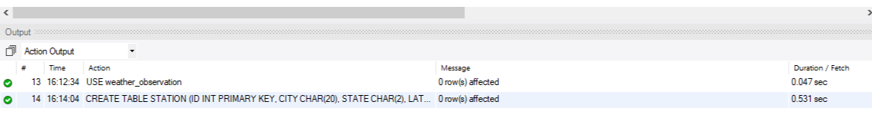

SELECT * FROM STATION; 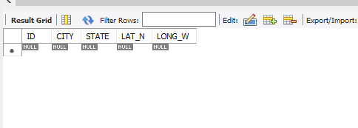

***-- Q2) Insert the following records into the table:***

INSERT INTO STATION (ID, CITY, STATE, LAT_N, LONG_W) VALUES (13,'PHOENIX','AZ',33,112),

(44,'DENVER','CO',40,105), (66,'CARIBOU','ME',47,68); 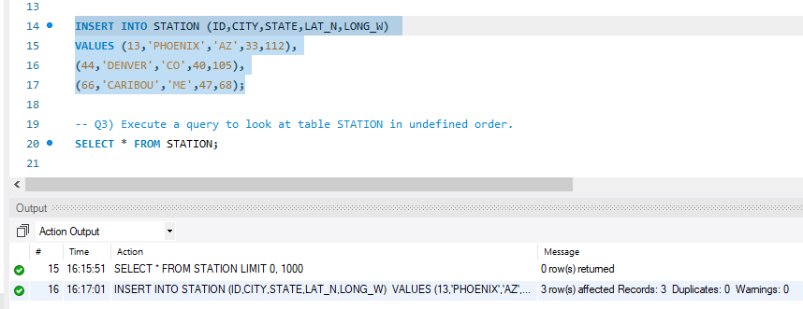

***-- Q3) Execute a query to look at table STATION in undefined order.***

SELECT * FROM STATION; 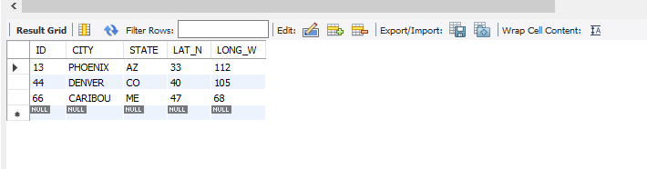

***-- Q4) Execute a query to select Northern stations (Northern latitude > 39.7).***

SELECT * FROM STATION

WHERE LAT_N>39.7; 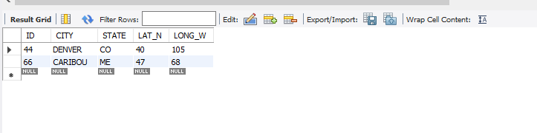

***-- Q5) Create another table, ‘STATS’, to store normalized temperature and precipitation data:***

CREATE TABLE STATS

(ID INT references STATION (ID),

MONTH INT CHECK (MONTH BETWEEN 1 AND 12),

TEMP_F REAL CHECK (TEMP_F BETWEEN -80 AND 150),

RAIN_I REAL CHECK ( RAIN_I BETWEEN 0 AND 100),

primary KEY(ID,MONTH));

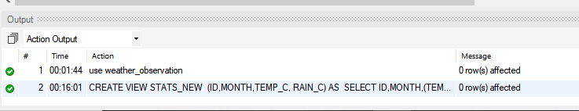

SELECT * FROM STATS;

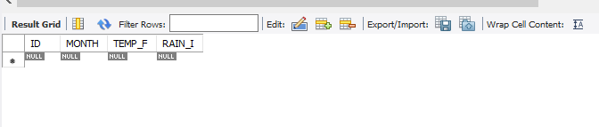

***-- Q6) Populate the table STATS with some statistics for January and July:***

INSERT INTO STATS (ID,MONTH,TEMP_F, RAIN_I) VALUES

(13,1,57.4,0.31),

(13,7,91.7,5.15),

(44,1,27.3,0.18),

(44,7,74.8,2.11),

(66,1,6.7,2.1),

(66,7,65.8,4.52);

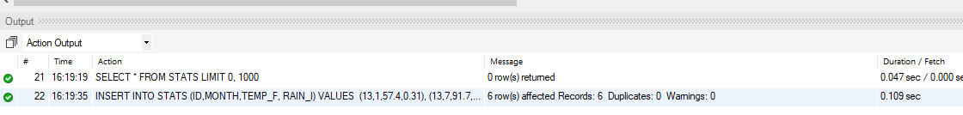

SELECT * FROM STATS;

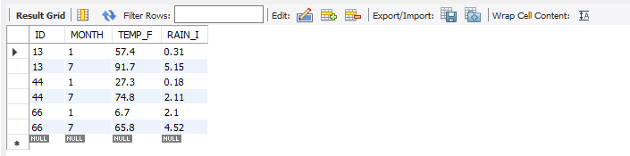

***-- Q7) Execute a query to display temperature stats (from the STATS table) for each city (from the STATION table).***

SELECT A.CITY , B.TEMP_F FROM STATION A JOIN STATS B ON A.ID = B.ID;

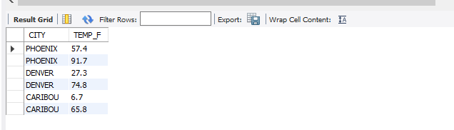

***-- Q8) Execute a query to look at the table STATS, ordered by month and greatest rainfall, with columns rearranged. It should also show the corresponding cities.***

SELECT * FROM STATS A JOIN STATION B ON A.ID = B.ID ORDER BY MONTH, RAIN_I DESC;

**“Or”**

SELECT A.ID, A.MONTH, A.TEMP_F, A.RAIN_I,B.CITY FROM STATS A,STATION B WHERE A.ID=B.ID ORDER BY A.MONTH, A.RAIN_I DESC;

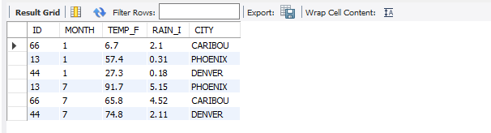

***-- Q9) Execute a query to look at temperatures for July from table STATS, lowest temperatures first, picking up city name and latitude.***

SELECT A.TEMP_F,B.CITY,B.LAT_N FROM STATS A JOIN STATION B ON A.ID=B.ID WHERE MONTH =7 ORDER BY TEMP_F;

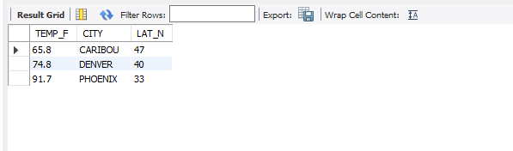

***-- Q10) Execute a query to show MAX and MIN temperatures as well as average rainfall for each city.***

SELECT MAX(A.TEMP_F),MIN(A.TEMP_F),ROUND(avg(A.RAIN_I),2) AS AVG_RAIN,B.CITY FROM STATS A

JOIN STATION B ON A.ID =B.ID group by B.CITY ;

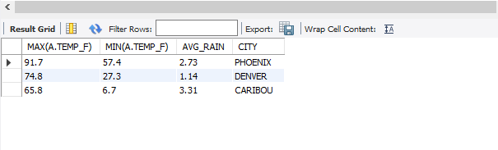

***-- Q11) Execute a query to display each city’s monthly temperature in Celcius and rainfall in Centimeter.***

CREATE VIEW STATS_NEW (ID,MONTH,TEMP_C, RAIN_C) AS

SELECT ID, MONTH,(TEMP_F-32)*5/9, RAIN_I*0.3937

FROM STATS;

SELECT * FROM STATS_NEW; 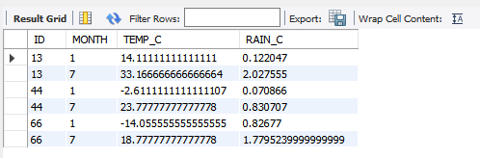

***-- Q12) Update all rows of table STATS to compensate for faulty rain gauges known to read 0.01 inches low.***

UPDATE STATS SET RAIN_I = RAIN_I+0.01; 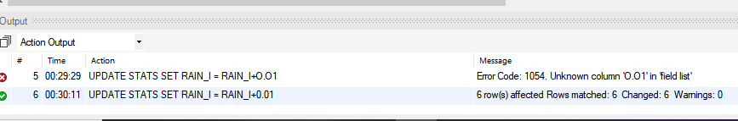

SELECT * FROM STATS; 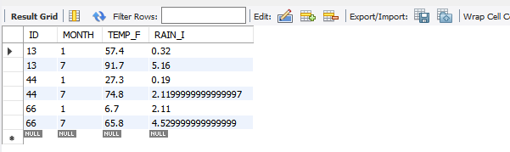

***-- Q13) Update Denver's July temperature reading as 74.9.***

UPDATE STATS SET TEMP_F = 74.9 WHERE MONTH= 7 AND ID=44; 